How to Use the Website as an Employee

Contents

Logging into the Dashboard Website 2

Logging out of the System 3

Upload a certification 4

# Logging into the Dashboard Website

1. Click Login

1. Click fill out the credentials then click login

1. You should not see any table Initially. Just the Welcome message. Once an Admin assigns roles to you then you will a similar screen to the image belowA picture containing timeline

   Description automatically generated

# Logging out of the System

1. Click logout

2. Clicking yes , will return to the login screen

# Upload a certification

1. Click Upload on the dashboard for the certification

1. You should see a screen like so

* 1. Clicking certification selection will show a list of certifications
     1. Graphical user interface, text, application

        Description automatically generated
  2. Clicking completion date will show a date selector
     1. A screen shot of a computer

        Description automatically generated with low confidence
  3. Clicking browse will open up your local system file explorer to upload a document. Uploading a certification will change the “No File Selected” text to change to the file name you selected

1. Once you have selected a certification and click upload. You will see a Valid confirmation for the certification and the date when it will expire
   1. 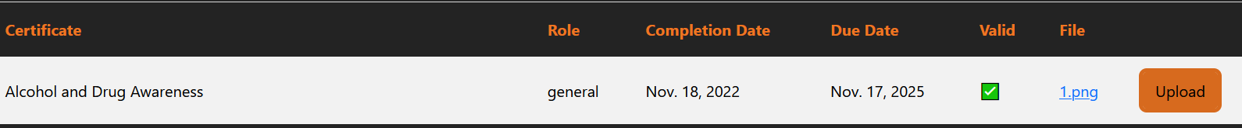
   2. You can also download the document in the future if you need again by clicking the file name